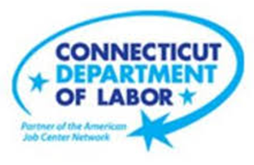

**NEW WEEKLY JOB POSTINGS FROM   
HELP WANTED ONLINE  
Office of Research**

**Week Ending April 30th, 2022: New Ads up to over 9,500**WETHERSFIELD, May 5th, 2022 – During the week ending April 30th, there were 9,556 new postings, up 305 new ads or +3% over the week. This is the second highest level of the past 12 weeks. This top line growth was driven by large increases in Manufacturing, Health Care, and Educational Services, which had over the week gains of 119 or more new ads. The total increase was tempered by large over the week drops in Pro., Sci., & Tech. Services, Retail Trade, and Finance & Insurance. Those three industries fell by 162 or more new ads. Employers with the largest increases include Raytheon (+142 new ads), Siemens (+125 new ads) and Travelers (+97 new ads). The week ending April 30th is the fifth that ended that during that month. The April 2022 average of weekly new ads was 8,652, which is the second highest in over a year and 46% higher than corresponding April 2021 levels. The weeks in April ranged between a high of 9,556 (ending April 30th) and a low of 6,837 (ending April 16th).   
  
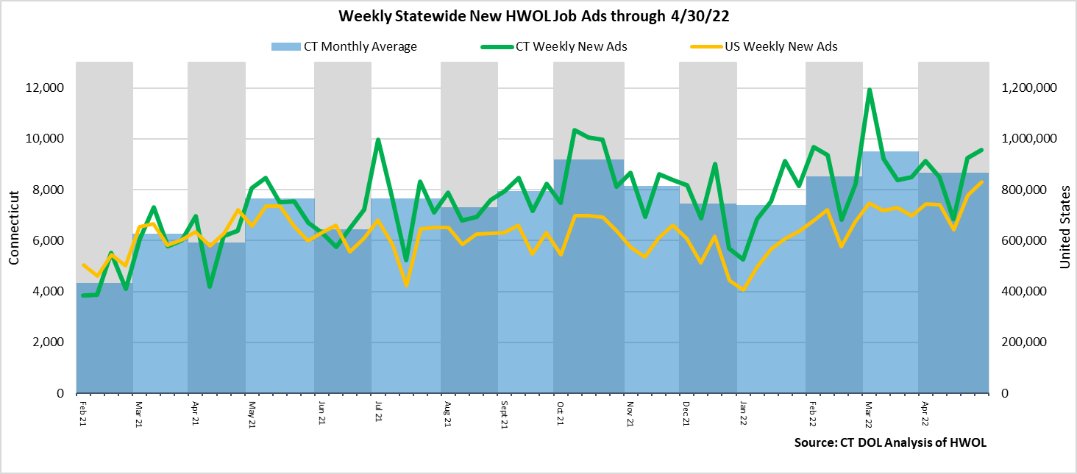  
**Industries** with the most new postings include Health Care & Social Assistance, Finance & Insurance, and   
Manufacturing.

**Occupations** with the most new postings include General & Operations Managers, Retail Salespersons, Wholesale & Manufacturing Sales Representatives.

**Employers** with the most new postings include Capital One, Raytheon, Yale-New Haven Health System.

**The three industries with the most new job postings were:**

* **Health Care & Social Assistance** (1,655 new postings, +24% over the week)
* **Finance & Insurance** (1,140 new postings, -12% over the week)
* **Manufacturing** (1,026 new postings, +60% over the week)

   
 During the week ending April 30th, the total ad increase of 305 new ads is the net result of change within 13 increasing and 8 decreasing. The 13 increasing industries grew by a combined 1,124 new ads. More than half of that combined increase occurred in Manufacturing (+385 new ads) and Health Care (+316 new ads). The eight decreasing industries fell by a combined 819 new ads. The largest industry decreases occurred within Professional, Scientific, & Technical Services (-419 new ads) and Retail Trade (-185 new ads). Over four weeks, new ads were up 410 postings and the result of 10 increasing and 11 decreasing industries. The largest of each over four weeks were Finance & Insurance (+348 new ads) and Health Care (-143 new ads).  
  
 For more information on total job ads by industry for Connecticut and its labor market areas, see the monthly report available here: <https://www1.ctdol.state.ct.us/lmi/hwol.asp>

**New Job Postings by Occupation** 

**The occupations with the most new postings were:**

* General and Operations Managers (369 new postings, +19% over the week)
* Retail Salespersons (221 new postings, -25% over the week)
* Sales Representatives, Wholesale & Manuf. (210 new ads, -17% over the week)

**Employers with the Most New Job Postings**

Employers with the most new job postings during the week were mostly in Finance & Insurance, Healthcare, and Professional, Scientific, & Technical Services. The 25 employers shown above account for 23 percent of all new ads. Among the top 25 employers, 21 had over the week ad increases and 4 had decreases. The largest top 25 employer increase over the week was Raytheon (+142 new ads) and the largest decreasing employer was PricewaterhouseCoopers (-560 new ads). Over four weeks, 23 of 25 employers shown above had increases and 2 had decreases. The largest of each was Capital One (+343 new ads) and Yale University (-26 new ads).

**What is HWOL?**The **Conference Board Help Wanted Online**® Data Series (HWOL) measures the number of new, first-time Online job postings and jobs reposted from the previous month for over 16,000 Internet job boards, corporate boards and smaller job sites that serve niche markets and smaller geographic areas. To view more HWOL data, go to: <https://www1.ctdol.state.ct.us/lmi/hwol.asp>